МИНИСТЕРСТВО НАУКИ И ВЫСШЕГО ОБРАЗОВАНИЯ   
РОССИЙСКОЙ ФЕДЕРАЦИИ

ФЕДЕРАЛЬНОЕ ГОСУДАРСТВЕННОЕ БЮДЖЕТНОЕ ОБРАЗОВАТЕЛЬНОЕ УЧРЕЖДЕНИЕ ВЫСШЕГО ОБРАЗОВАНИЯ

**«БЕЛГОРОДСКИЙ ГОСУДАРСТВЕННЫЙ**

**ТЕХНОЛОГИЧЕСКИЙ УНИВЕРСИТЕТ им. В. Г. ШУХОВА»**

**(БГТУ им. В.Г. Шухова)**

Кафедра программного обеспечения вычислительной техники и автоматизированных систем

Лабораторная работа №5

по дисциплине: Теория цифровых автоматов

тема: «Синтез и анализ многовыходных комбинационных схем

в базисе И-ИЛИ-НЕ»

Выполнил: ст. группы ВТ-32

Воскобойников И. С.

Проверил: Рязанов Ю. Д,

Белгород 2020 г.

**Цель работы**: научиться строить эффективные по быстродействию и затратам оборудования многовыходные комбинационные схемы.

Задание

1. Составить таблицу истинности системы булевых функций, которая состоит из трех функций f1(X), f2(X) и f3(X), где X = {x1, x2, x3, x4, x5}. Булева функция fi(X) для k-го варианта определяется как fi(X) = gk+i–1(X)∧ gk+3(X), где gj(X) — булева функция, представленная в таблице 1 (см. лабораторную работу № 1) в строке j. Для составления таблицы истинности рекомендуется написать программу.

2. Получить систему минимальных дизъюнктивных нормальных форм булевых функций f1(X), f2(X) и f3(X).

3. Применить факторизационный метод синтеза многоярусной комбинационной схемы в базисе И-ИЛИ-НЕ с двухвходовыми элементами И и ИЛИ по системе минимальных дизъюнктивных нормальных форм булевых функций f1(X), f2(X) и f3(X).

4.Получить минимальную дизъюнктивную нормальную форму системы булевых функций f1(X), f2(X) и f3(X).

5.Применить факторизационный метод синтеза многоярусной комбинационной схемы в базисе И-ИЛИ-НЕ с двухвходовыми элементами И и ИЛИ по минимальной дизъюнктивной нормальной форме системы булевых функций f1(X), f2(X) и f3(X).

6. Написать программы, моделирующие работу схем, полученных в пунктах 3 и 5, на всех входных наборах и строящие таблицу истинности каждой схемы. Сравнить полученные таблицы истинности с таблицей истинности исходной системы булевых функций.

7.Сравнить полученные в пунктах 3 и 5 схемы по Квайну и по быстродействию.

1. Составить таблицу истинности системы булевых функций, которая состоит из трех функций f1(X), f2(X) и f3(X), где X = {x1, x2, x3, x4, x5}. Булева функция fi(X) для k-го варианта определяется как fi(X) = gk+i–1(X)∧ gk+3(X), где gj(X) — булева функция, представленная в таблице 1 (см. лабораторную работу № 1) в строке j. Для составления таблицы истинности рекомендуется написать программу.

|  |  |  |  |  |  |  |  |
| --- | --- | --- | --- | --- | --- | --- | --- |
|  |  |  |  |  |  |  |  |
| 0 | 0 | 0 | 0 | 0 | 0 | 0 | 0 |
| 0 | 0 | 0 | 0 | 1 | 0 | 0 | 0 |
| 0 | 0 | 0 | 1 | 0 | 0 | 0 | 0 |
| 0 | 0 | 0 | 1 | 1 | 0 | 0 | 0 |
| 0 | 0 | 1 | 0 | 0 | 0 | 1 | 1 |
| 0 | 0 | 1 | 0 | 1 | 0 | 0 | 0 |
| 0 | 0 | 1 | 1 | 0 | 0 | 1 | 0 |
| 0 | 0 | 1 | 1 | 1 | 0 | 1 | 0 |
| 0 | 1 | 0 | 0 | 0 | 0 | 1 | 0 |
| 0 | 1 | 0 | 0 | 1 | 0 | 1 | 0 |
| 0 | 1 | 0 | 1 | 0 | 0 | 0 | 0 |
| 0 | 1 | 0 | 1 | 1 | 1 | 1 | 0 |
| 0 | 1 | 1 | 0 | 0 | 0 | 0 | 0 |
| 0 | 1 | 1 | 0 | 1 | 0 | 0 | 1 |
| 0 | 1 | 1 | 1 | 0 | 1 | 0 | 1 |
| 0 | 1 | 1 | 1 | 1 | 0 | 0 | 0 |
| 1 | 0 | 0 | 0 | 0 | 0 | 0 | 0 |
| 1 | 0 | 0 | 0 | 1 | 0 | 0 | 0 |
| 1 | 0 | 0 | 1 | 0 | 0 | 0 | 0 |
| 1 | 0 | 0 | 1 | 1 | 0 | 0 | 0 |
| 1 | 0 | 1 | 0 | 0 | 1 | 1 | 1 |
| 1 | 0 | 1 | 0 | 1 | 0 | 1 | 1 |
| 1 | 0 | 1 | 1 | 0 | 0 | 0 | 0 |
| 1 | 0 | 1 | 1 | 1 | 1 | 1 | 0 |
| 1 | 1 | 0 | 0 | 0 | 0 | 0 | 0 |
| 1 | 1 | 0 | 0 | 1 | 0 | 0 | 0 |
| 1 | 1 | 0 | 1 | 0 | 0 | 0 | 0 |
| 1 | 1 | 0 | 1 | 1 | 0 | 0 | 0 |
| 1 | 1 | 1 | 0 | 0 | 0 | 0 | 0 |
| 1 | 1 | 1 | 0 | 1 | 0 | 0 | 0 |
| 1 | 1 | 1 | 1 | 0 | 0 | 0 | 0 |
| 1 | 1 | 1 | 1 | 1 | 0 | 0 | 0 |

2. Получить систему минимальных дизъюнктивных нормальных форм булевых функций f1(X), f2(X) и f3(X).

F1 СДНФ :

|  |  |  |  |  |  |
| --- | --- | --- | --- | --- | --- |
| 0 | 1 | 2 | 3 | 4 | 5 |
|  |  | 10100 | 01011  01110 | 10111 |  |

Минимальная ДНФ:

F2 СДНФ :

|  |  |  |  |  |  |
| --- | --- | --- | --- | --- | --- |
| 0 | 1 | 2 | 3 | 4 | 5 |
|  | 00100+  00100+ | 00110+  01001+  10100+ | 00111+  01011+  10101+ | 10111+ |  |
|  | 001-0 -0100 0100- | 0011-  010-1 1010- | -0111 101-1 |  |  |

|  |  |  |  |  |  |  |  |  |  |
| --- | --- | --- | --- | --- | --- | --- | --- | --- | --- |
|  | 00100 | 01000 | 00110 | 01001 | 10100 | 00111 | 01011 | 10101 | 10111 |
| 001-0 | + |  | + |  |  |  |  |  |  |
| -0100 | + |  |  |  | + |  |  |  |  |
| 0100- |  | + |  | + |  |  |  |  |  |
| 0011- |  |  | + |  |  | + |  |  |  |
| 010-1 |  |  |  | + |  |  | + |  |  |
| 1010- |  |  |  |  | + |  |  | + |  |
| -0111 |  |  |  |  |  | + |  |  | + |
| 101-1 |  |  |  |  |  |  |  | + | + |

Минимальная ДНФ:

F3 СДНФ :

|  |  |  |  |  |  |
| --- | --- | --- | --- | --- | --- |
| 0 | 1 | 2 | 3 | 4 | 5 |
|  | 00100+ | 10100+ | 01101  01110  10101+ |  |  |
|  | -0100 | 1010- |  |  |  |

|  |  |  |  |  |  |
| --- | --- | --- | --- | --- | --- |
|  | 00100 | 10100 | 01101 | 01110 | 10101 |
| -0100 | + | + |  |  |  |
| 1010- |  | + |  |  | + |
| 01101 |  |  | + |  |  |
| 01110 |  |  |  | + |  |

Минимальная ДНФ:

3. Применить факторизационный метод синтеза многоярусной комбинационной схемы в базисе И-ИЛИ-НЕ с двухвходовыми элементами И и ИЛИ по системе минимальных дизъюнктивных нормальных форм булевых функций f1(X), f2(X) и f3(X).

|  |  |  |  |  |  |  |  |  |  |  |  |  |  |  |  |  |  |  |  |  |  |  |  |  |  |
| --- | --- | --- | --- | --- | --- | --- | --- | --- | --- | --- | --- | --- | --- | --- | --- | --- | --- | --- | --- | --- | --- | --- | --- | --- | --- |
|  |  |  |  |  |  |  |  |  |  |  |  |  |  |  |  |  |  |  |  |  |  |  |  |  |  |
|  | 1* | 0 | 0 | 1* | 1* | 0 | 0 | 1* | 0 | 1* | 0 | 1* | 0 | 1 | 1 | 0 | 0 | 0 | 0 | 0 | 0 | 0 | 0 | 0 | 0 |
|  | 0 | 1* | 1* | 0 | 0 | 1* | 1* | 0 | 1* | 0 | 1 | 0 | 0 | 0 | 0 | 1 | 0 | 0 | 0 | 0 | 0 | 0 | 0 | 0 | 0 |
|  | 0 | 1* | 1* | 0 | 1* | 0 | 1* | 0 | 0 | 1* | 1 | 0 | 0 | 0 | 0 | 0 | 1 | 0 | 0 | 0 | 0 | 0 | 0 | 0 | 0 |
|  | 0 | 0 | 0 | 1* | 1* | 0 | 1* | 0 | 1* | 0 | 0 | 1 | 0 | 0 | 0 | 0 | 0 | 1 | 0 | 0 | 0 | 0 | 0 | 0 | 0 |
|  | 0 | 0 | 0 | 1* | 1* | 0 | 0 | 1* | 0 | 1* | 0 | 1 | 0 | 0 | 0 | 0 | 0 | 0 | 1 | 0 | 0 | 0 | 0 | 0 | 0 |
|  | 0 | 1* | 1* | 0 | 0 | 1* | 0 | 1* | 0 | 0 | 0 | 0 | 1 | 0 | 0 | 0 | 0 | 0 | 0 | 1 | 0 | 0 | 0 | 0 | 0 |
|  | 0 | 1* | 0 | 1* | 1* | 0 | 1* | 0 | 0 | 0 | 0 | 1 | 0 | 0 | 0 | 0 | 0 | 0 | 0 | 0 | 1 | 0 | 0 | 0 | 0 |
|  | 0 | 1* | 1* | 0 | 0 | 1* | 0 | 0 | 1* | 0 | 0 | 0 | 1 | 0 | 0 | 1 | 0 | 0 | 0 | 0 | 0 | 0 | 0 | 0 | 0 |
|  | 1* | 0 | 0 | 1* | 1* | 0 | 0 | 0 | 1* | 0 | 0 | 1 | 0 | 1 | 0 | 0 | 0 | 0 | 0 | 0 | 0 | 0 | 0 | 0 | 0 |
|  | 1* | 0 | 0 | 1* | 1* | 0 | 0 | 1* | 0 | 0 | 0 | 1 | 0 | 0 | 0 | 0 | 0 | 0 | 0 | 0 | 0 | 1 | 0 | 0 | 0 |
|  | 0 | 1* | 1* | 0 | 1* | 0 | 0 | 1* | 1* | 0 | 0 | 0 | 1* | 0 | 0 | 0 | 0 | 0 | 0 | 0 | 0 | 0 | 1 | 1 | 0 |
|  | 0 | 1 | 1* | 0 | 0 | 0 | 1* | 0 | 0 | 0 | 0 | 0 | 0 | 0 | 0 | 0 | 0 | 0 | 0 | 0 | 0 | 0 | 0 | 0 | 1 |
|  | 0 | 0 | 0 | 1 | 1 | 0 | 0 | 0 | 0 | 0 | 0 | 0 | 0 | 0 | 0 | 0 | 0 | 0 | 0 | 0 | 0 | 0 | 0 | 0 | 0 |
|  | 0 | 1 | 1 | 0 | 0 | 0 | 0 | 0 | 0 | 0 | 0 | 0 | 0 | 0 | 0 | 0 | 0 | 0 | 0 | 0 | 0 | 0 | 0 | 0 | 0 |
|  | 1 | 0 | 0 | 0 | 0 | 0 | 0 | 0 | 1 | 0 | 0 | 0 | 0 | 0 | 0 | 0 | 0 | 0 | 0 | 0 | 0 | 0 | 0 | 0 | 0 |
|  | 0 | 0 | 0 | 0 | 0 | 0 | 0 | 0 | 0 | 1 | 0 | 1 | 0 | 0 | 0 | 0 | 0 | 0 | 0 | 0 | 0 | 0 | 0 | 0 | 0 |
|  | 0 | 0 | 0 | 0 | 0 | 1 | 0 | 0 | 1 | 0 | 0 | 0 | 0 | 0 | 0 | 0 | 0 | 0 | 0 | 0 | 0 | 0 | 0 | 0 | 0 |
|  | 0 | 0 | 0 | 0 | 1 | 0 | 0 | 0 | 0 | 1 | 0 | 0 | 0 | 0 | 0 | 0 | 0 | 0 | 0 | 0 | 0 | 0 | 0 | 0 | 0 |
|  | 0 | 0 | 0 | 0 | 0 | 0 | 1 | 0 | 1 | 0 | 0 | 0 | 0 | 0 | 0 | 0 | 0 | 0 | 0 | 0 | 0 | 0 | 0 | 0 | 0 |
|  | 0 | 0 | 0 | 0 | 0 | 0 | 0 | 1 | 0 | 1 | 0 | 0 | 0 | 0 | 0 | 0 | 0 | 0 | 0 | 0 | 0 | 0 | 0 | 0 | 0 |
|  | 0 | 0 | 0 | 0 | 0 | 1 | 0 | 1 | 0 | 0 | 0 | 0 | 0 | 0 | 0 | 0 | 0 | 0 | 0 | 0 | 0 | 0 | 0 | 0 | 0 |
|  | 0 | 1 | 0 | 0 | 0 | 0 | 1 | 0 | 0 | 0 | 0 | 0 | 0 | 0 | 0 | 0 | 0 | 0 | 0 | 0 | 0 | 0 | 0 | 0 | 0 |
|  | 1 | 0 | 0 | 0 | 0 | 0 | 0 | 1 | 0 | 0 | 0 | 0 | 0 | 0 | 0 | 0 | 0 | 0 | 0 | 0 | 0 | 0 | 0 | 0 | 0 |
|  | 0 | 0 | 0 | 0 | 1 | 0 | 0 | 1 | 0 | 0 | 0 | 0 | 0 | 0 | 0 | 0 | 0 | 0 | 0 | 0 | 0 | 0 | 0 | 0 | 0 |
|  | 0 | 0 | 0 | 0 | 0 | 0 | 0 | 0 | 1 | 0 | 0 | 0 | 1 | 0 | 0 | 0 | 0 | 0 | 0 | 0 | 0 | 0 | 0 | 0 | 0 |
|  | 0 | 0 | 1 | 0 | 0 | 0 | 1 | 0 | 0 | 0 | 0 | 0 | 0 | 0 | 0 | 0 | 0 | 0 | 0 | 0 | 0 | 0 | 0 | 0 | 0 |

|  |  |  |  |  |  |  |  |  |  |  |  |  |  |  |  |  |  |  |
| --- | --- | --- | --- | --- | --- | --- | --- | --- | --- | --- | --- | --- | --- | --- | --- | --- | --- | --- |
|  |  |  |  |  |  |  |  |  |  |  |  |  |  |  |  |  |  |  |
|  | 1* | 1* | 1* | 1* | 0 | 0 | 0 | 0 | 0 | 0 | 0 | 1 | 1 | 0 | 0 | 0 | 0 | 0 |
|  | 0 | 0 | 0 | 0 | 1* | 1* | 1* | 1* | 1* | 0 | 0 | 0 | 0 | 1* | 1 | 1 | 0 | 0 |
|  | 0 | 0 | 1* | 0 | 1* | 0 | 0 | 0 | 0 | 1* | 1* | 0 | 0 | 0 | 0 | 0 | 1 | 1 |
|  | 1 | 1 | 0 | 0 | 0 | 0 | 0 | 0 | 0 | 0 | 0 | 0 | 0 | 0 | 0 | 0 | 0 | 0 |
|  | 0 | 0 | 1 | 1 | 0 | 0 | 0 | 0 | 0 | 0 | 0 | 0 | 0 | 0 | 0 | 0 | 0 | 0 |
|  | 0 | 0 | 0 | 0 | 1 | 1 | 0 | 0 | 0 | 0 | 0 | 0 | 0 | 0 | 0 | 0 | 0 | 0 |
|  | 0 | 0 | 0 | 0 | 0 | 0 | 1 | 1 | 0 | 0 | 0 | 0 | 0 | 0 | 0 | 0 | 0 | 0 |
|  | 0 | 0 | 0 | 0 | 0 | 0 | 0 | 0 | 1 | 0 | 0 | 0 | 0 | 1 | 0 | 0 | 0 | 0 |
|  | 0 | 0 | 1 | 0 | 1 | 0 | 0 | 0 | 0 | 0 | 0 | 0 | 0 | 0 | 0 | 0 | 0 | 0 |
|  | 0 | 0 | 0 | 0 | 0 | 0 | 0 | 0 | 0 | 1 | 1 | 0 | 0 | 0 | 0 | 0 | 0 | 0 |

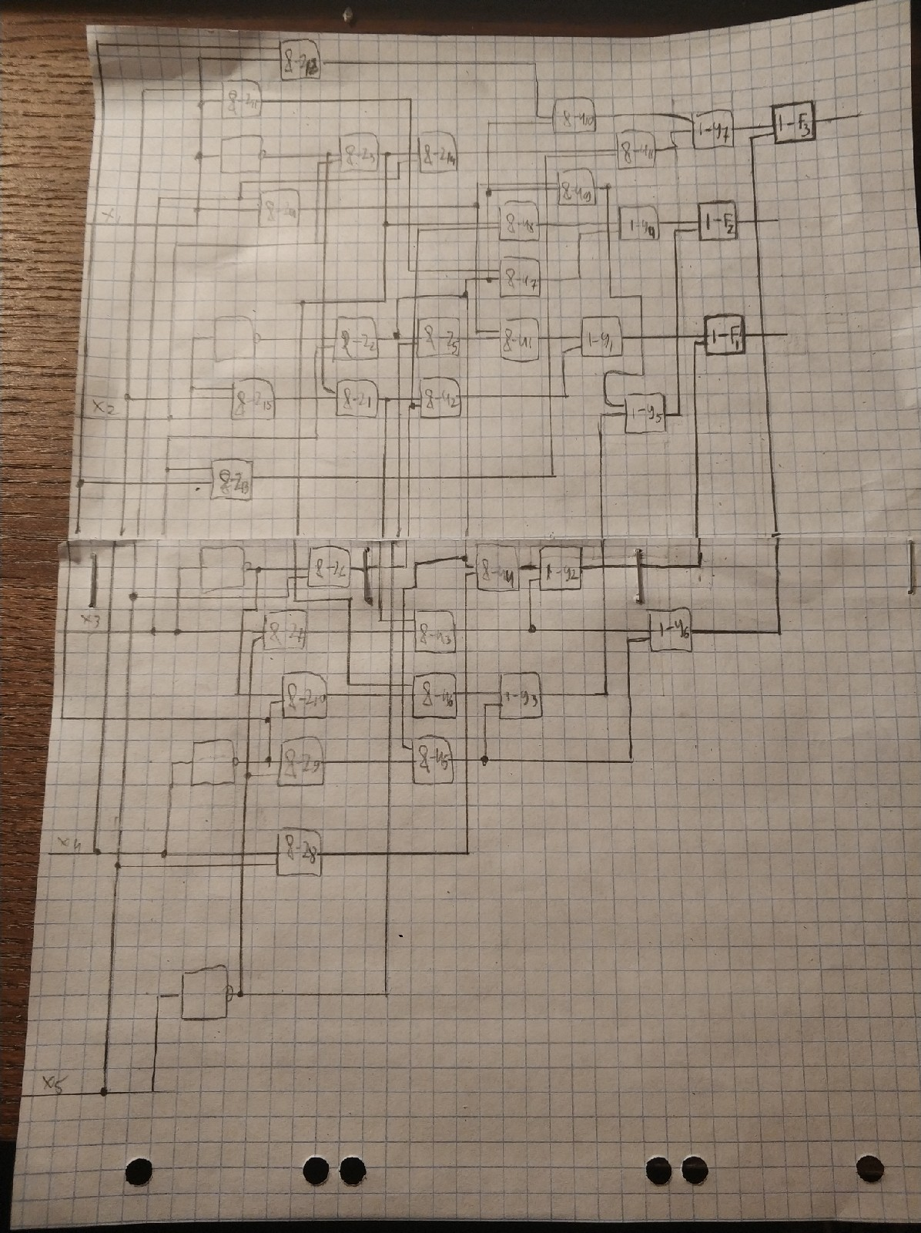

4.Получить минимальную дизъюнктивную нормальную форму системы булевых функций f1(X), f2(X) и f3(X).

|  |  |  |  |  |  |
| --- | --- | --- | --- | --- | --- |
| 0 | 1 | 2 | 3 | 4 | 5 |
|  | 00100(2,3)+  01000(2)+ | 00110(2)+  01001(2)+  10100(2,1,3)+ | 00111(2)+  01011(1,2)  01101(3)  01110(1,3)  10101(2,3)+ | 10111(2,1) |  |
|  | 001-0(2)  -0100(2,3)  0100-(2) | 0011-(2)  010-1(2)  1010-(2,3) | -0111(2)  101-1(2) |  |  |

|  |  |  |  |  |  |  |  |  |  |  |  |  |  |  |  |  |  |  |
| --- | --- | --- | --- | --- | --- | --- | --- | --- | --- | --- | --- | --- | --- | --- | --- | --- | --- | --- |
|  |  | | | |  | | | | | | | | |  | | | | |
|  | 10100 | 01011 | 01110 | 10111 | 00100 | 01000 | 00110 | 01001 | 10100 | 00111 | 01011 | 10101 | 10111 | 00100 | 10100 | 01101 | 01110 | 10101 |
| 001-0(2) |  |  |  |  | + |  | + |  |  |  |  |  |  |  |  |  |  |  |
| -0100(2,3) |  |  |  |  | + |  |  |  | + |  |  |  |  | + | + |  |  |  |
| 0100-(2) |  |  |  |  |  | + |  | + |  |  |  |  |  |  |  |  |  |  |
| 0011-(2) |  |  |  |  |  |  | + |  |  | + |  |  |  |  |  |  |  |  |
| 010-1(2) |  |  |  |  |  |  |  | + |  |  | + |  |  |  |  |  |  |  |
| 1010-(2,3) |  |  |  |  |  |  |  |  | + |  |  | + |  |  | + |  |  | + |
| -0111(2) |  |  |  |  |  |  |  |  |  | + |  |  | + |  |  |  |  |  |
| 101-1(2) |  |  |  |  |  |  |  |  |  |  |  | + | + |  |  |  |  |  |
| 10100(1,2,3) | + |  |  |  |  |  |  |  | + |  |  |  |  |  | + |  |  |  |
| 01011(1,2) |  | + |  |  |  |  |  |  |  |  | + |  |  |  |  |  |  |  |
| 01101(3) |  |  |  |  |  |  |  |  |  |  |  |  |  |  |  | + |  |  |
| 01110(1,3) |  |  | + |  |  |  |  |  |  |  |  |  |  |  |  |  | + |  |
| 10111(1,2) |  |  |  | + |  |  |  |  |  |  |  |  | + |  |  |  |  |  |

|  |  |  |  |  |  |  |  |  |  |  |  |  |  |  |  |  |  |  |  |  |  |  |  |
| --- | --- | --- | --- | --- | --- | --- | --- | --- | --- | --- | --- | --- | --- | --- | --- | --- | --- | --- | --- | --- | --- | --- | --- |
|  |  |  |  |  |  |  |  |  |  |  |  |  |  |  |  |  |  |  |  |  |  |  |  |
|  | 1* | 0 | 0 | 1* | 1* | 0 | 0 | 1* | 0 | 1* | 0 | 1* | 1 | 1 | 0 | 0 | 0 | 0 | 0 | 0 | 0 | 0 | 0 |
|  | 0 | 1* | 1* | 0 | 0 | 1* | 1* | 0 | 1* | 0 | 1* | 0 | 0 | 0 | 1 | 1 | 0 | 0 | 0 | 0 | 0 | 0 | 0 |
|  | 0 | 1* | 1* | 0 | 1* | 0 | 1* | 0 | 0 | 1* | 1* | 0 | 0 | 0 | 1 |  | 1 | 0 | 0 | 0 | 0 | 0 | 0 |
|  | 1* | 0 | 0 | 1* | 1* | 0 | 1* | 0 | 1* | 0 | 0 | 1* | 0 | 0 | 0 | 0 | 0 | 1 | 1 | 0 | 0 | 0 | 0 |
|  | 0 | 0 | 0 | 1* | 1* | 0 | 0 | 1* | 0 | 1* | 0 | 1 | 0 | 0 | 0 | 0 | 0 | 0 | 0 | 1 | 0 | 0 | 0 |
|  | 0 | 1* | 1* | 0 | 0 | 1* | 0 | 1* | 0 | 0 | 1 | 0 | 0 | 0 | 0 | 0 | 0 | 0 | 0 | 0 | 1 | 0 | 0 |
|  | 0 | 1 | 0 | 1* | 1* | 0 | 1* | 0 | 0 | 0 | 0 | 1* | 0 | 0 | 0 | 0 | 0 | 1 | 0 | 0 | 0 | 0 | 0 |
|  | 1* | 0 | 0 | 1* | 1* | 0 | 0 | 1* | 0 | 0 | 0 | 1 | 1 | 0 | 0 | 0 | 0 | 0 | 0 | 0 | 0 | 0 | 0 |
|  | 0 | 1* | 1* | 0 | 1* | 0 | 0 | 1* | 1* | 0 | 1* | 0 | 0 | 0 | 0 | 0 | 0 | 0 | 0 | 0 | 0 | 1 | 1 |
|  | 0 | 1 | 1 | 0 | 0 | 0 | 0 | 0 | 0 | 0 | 0 | 0 | 0 | 0 | 0 | 0 | 0 | 0 | 0 | 0 | 0 | 0 | 0 |
|  | 0 | 0 | 0 | 1 | 1 | 0 | 0 | 0 | 0 | 0 | 0 | 0 | 0 | 0 | 0 | 0 | 0 | 0 | 0 | 0 | 0 | 0 | 0 |
|  | 1 | 0 | 0 | 0 | 0 | 0 | 0 | 1 | 0 | 0 | 0 | 0 | 0 | 0 | 0 | 0 | 0 | 0 | 0 | 0 | 0 | 0 | 0 |
|  | 0 | 0 | 0 | 0 | 0 | 0 | 0 | 0 | 0 | 1 | 0 | 1 | 0 | 0 | 0 | 0 | 0 | 0 | 0 | 0 | 0 | 0 | 0 |
|  | 0 | 0 | 0 | 0 | 0 | 0 | 1 | 0 | 0 | 0 | 1 | 0 | 0 | 0 | 0 | 0 | 0 | 0 | 0 | 0 | 0 | 0 | 0 |
|  | 0 | 0 | 0 | 0 | 0 | 1 | 0 | 0 | 1 | 0 | 0 | 0 | 0 | 0 | 0 | 0 | 0 | 0 | 0 | 0 | 0 | 0 | 0 |
|  | 0 | 0 | 0 | 0 | 1 | 0 | 0 | 0 | 0 | 1 | 0 | 0 | 0 | 0 | 0 | 0 | 0 | 0 | 0 | 0 | 0 | 0 | 0 |
|  | 0 | 0 | 0 | 0 | 0 | 0 | 1 | 0 | 0 | 0 | 0 | 1 | 0 | 0 | 0 | 0 | 0 | 0 | 0 | 0 | 0 | 0 | 0 |
|  | 1 | 0 | 0 | 0 | 0 | 0 | 0 | 0 | 1 | 0 | 0 | 0 | 0 | 0 | 0 | 0 | 0 | 0 | 0 | 0 | 0 | 0 | 0 |
|  | 0 | 0 | 0 | 0 | 0 | 0 | 0 | 1 | 0 | 1 | 0 | 0 | 0 | 0 | 0 | 0 | 0 | 0 | 0 | 0 | 0 | 0 | 0 |
|  | 0 | 0 | 0 | 0 | 0 | 1 | 0 | 1 | 0 | 0 | 0 | 0 | 0 | 0 | 0 | 0 | 0 | 0 | 0 | 0 | 0 | 0 | 0 |
|  | 0 | 0 | 0 | 0 | 1 | 0 | 0 | 1 | 0 | 0 | 0 | 0 | 0 | 0 | 0 | 0 | 0 | 0 | 0 | 0 | 0 | 0 | 0 |
|  | 0 | 0 | 0 | 0 | 0 | 0 | 0 | 0 | 1 | 0 | 1 | 0 | 0 | 0 | 0 | 0 | 0 | 0 | 0 | 0 | 0 | 0 | 0 |

|  |  |  |  |  |  |  |  |  |  |  |  |  |  |  |  |  |  |
| --- | --- | --- | --- | --- | --- | --- | --- | --- | --- | --- | --- | --- | --- | --- | --- | --- | --- |
|  |  |  |  |  |  |  |  |  |  |  |  |  |  |  |  |  |  |
|  | 1* | 1* | 1* | 1* | 0 | 0 | 0 | 0 | 0 | 1 | 1 | 0 | 0 | 0 | 0 | 0 | 0 |
|  | 1* | 1* | 0 | 1* | 1* | 1* | 1* | 1* | 0 | 1* | 0 | 1* | 1* | 1 | 1 | 0 | 0 |
|  | 0 | 0 | 1* | 0 | 1* | 0 | 0 | 1* | 1* | 0 | 0 | 0 | 0 | 0 | 0 | 1 | 1 |
|  | 1 | 1 | 0 | 0 | 0 | 0 | 0 | 0 | 0 | 0 | 0 | 0 | 0 | 0 | 0 | 0 | 0 |
|  | 0 | 0 | 1 | 1 | 0 | 0 | 0 | 0 | 0 | 0 | 0 | 0 | 0 | 0 | 0 | 0 | 0 |
|  | 0 | 0 | 0 | 1 | 1 | 0 | 0 | 0 | 0 | 0 | 0 | 0 | 0 | 0 | 0 | 0 | 0 |
|  | 0 | 0 | 0 | 0 | 0 | 1 | 1 | 0 | 0 | 0 | 0 | 0 | 0 | 0 | 0 | 0 | 0 |
|  | 0 | 0 | 0 | 0 | 0 | 0 | 0 | 1 | 0 | 1 | 0 | 0 | 0 | 0 | 0 | 0 | 0 |
|  | 0 | 0 | 0 | 0 | 0 | 0 | 0 | 0 | 0 | 0 | 0 | 1 | 1 | 0 | 0 | 0 | 0 |
|  | 0 | 0 | 1 | 0 | 1 | 0 | 0 | 0 | 0 | 0 | 0 | 0 | 0 | 0 | 0 | 0 | 0 |
|  | 0 | 0 | 0 | 0 | 0 | 0 | 0 | 1 | 1 | 0 | 0 | 0 | 0 | 0 | 0 | 0 | 0 |

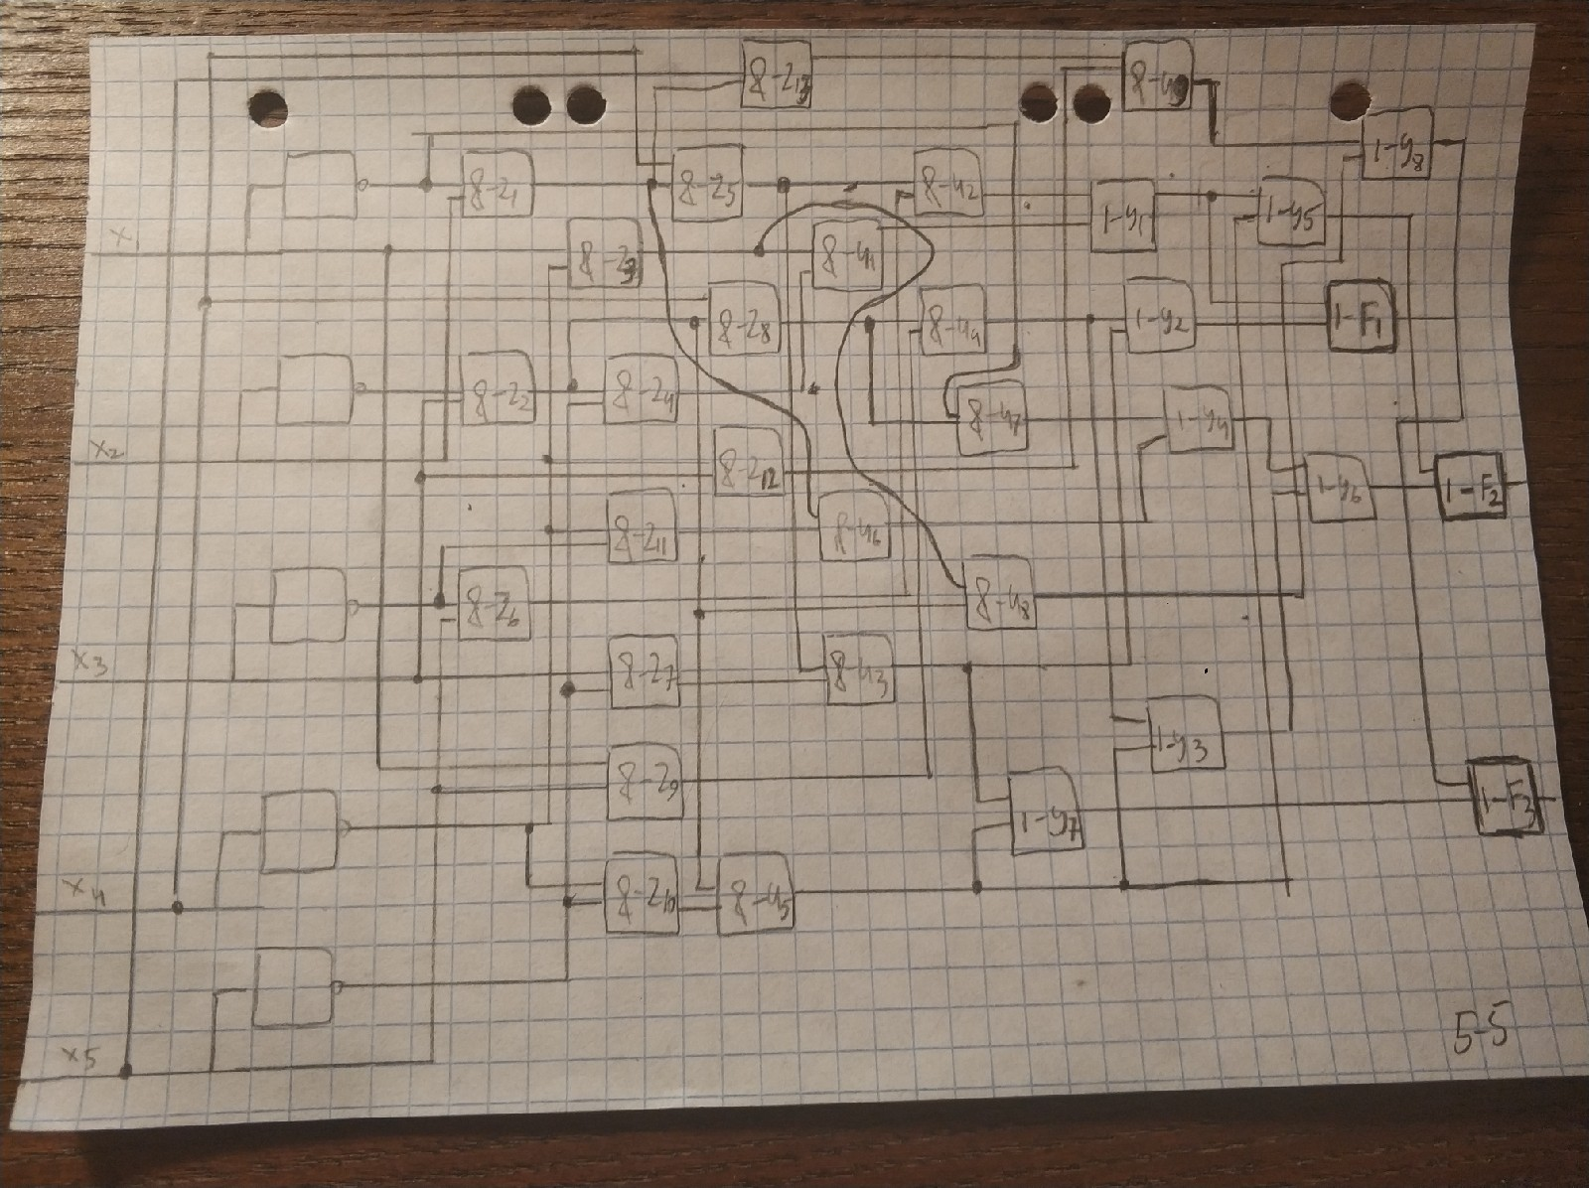

6. Написать программы, моделирующие работу схем, полученных в пунктах 3 и 5, на всех входных наборах и строящие таблицу истинности каждой схемы. Сравнить полученные таблицы истинности с таблицей истинности исходной системы булевых функций.

void function_3(bool *x, bool &f1, bool &f2, bool &f3) *//моделирование работы схемы 3*{  
   
  
 bool z2 = !x[1] && x[2],  
 z3 = !x[0] && x[1],  
 z4 = x[0] && x[4],  
 z5 = !x[4] && z2,  
 z6 = !x[2] && x[4],  
 z7 = x[2] && !x[4],  
 z8 = x[3] && x[4],  
 z9 = !x[3] && !x[4],  
 z10 = !x[2] &&!x[3],  
 z11 = !x[0] && x[3],  
 z12 = x[0] && !x[3],  
 z13 = x[2] && !x[3],  
 z14 = x[4] && z3,  
 z15 = x[1] && x[3],  
 z1 = !x[0] &&z15;  
  
 bool u1 = z4 && z5,  
 u2 = z1 && z6,  
 u3 = z1 && z7,  
 u4 = z2 && z8,  
 u5 = z2 && z9,  
 u6 = z3 && z10,  
 u7 = z2 && z11,  
 u8 = z3 && z6,  
 u9 = z2 &&z4,  
 u10 = z2 & z12,  
 u11 = z13 && z14;  
  
 bool y1 = u1 || u2,  
 y2 = u3 || u4,  
 y3 = u5 || u6,  
 y4 = u7 || u8,  
 y5 = u9 || y3,  
 y6 = u5 || u3,  
 y7 = u10 ||u11;  
  
f1 = y1 || y2;  
f2 = y4 || y5;  
f3 = y6 || y7;  
  
}  
  
  
void function_6(bool *x, bool &f1, bool &f2, bool &f3) *//моделирование работы схемы 6*{  
  
 bool z1 = !x[0] && x[1],  
 z2 = !x[1] && x[2],  
 z3 = x[0] && !x[3],  
 z4 = !x[4] && z2,  
 z5 = x[3] && z1,  
 z6 = !x[2] && x[4],  
 z7 = x[2] && !x[4],  
 z8 = x[3] && z2,  
 z9 = x[0] && x[4],  
 z10 =!x[3] && !x[4],  
 z11 = !x[2] && !x[3],  
 z12 = x[2] && !x[3],  
 z13 = x[4] && z1;  
  
 bool u1 = z3 && z4,  
 u2 = z5 && z6,  
 u3 = z5 && z7,  
 u4 = z8 && z9,  
 u5 = z2 && z10,  
 u6 = z1 && z11,  
 u7 = !x[0] && z8,  
 u8 = z2 && z3,  
 u9 = z12 &&z13;  
  
 bool y1 = u1 || u2,  
 y2 = u3 || u4,  
 y3 = u4 || u5,  
 y4 = u6 || u7,  
 y5 = u8 || y1,  
 y6 = y3 || y4,  
 y7 = u3 || u5,  
 y8 = u8 || u9;  
  
 f1 = y1 || y2;  
 f2 = y5 || y6;  
 f3 = y7 || y8;  
  
}

схема 3 пункта

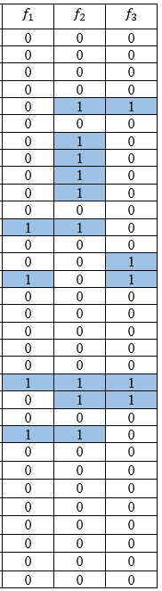

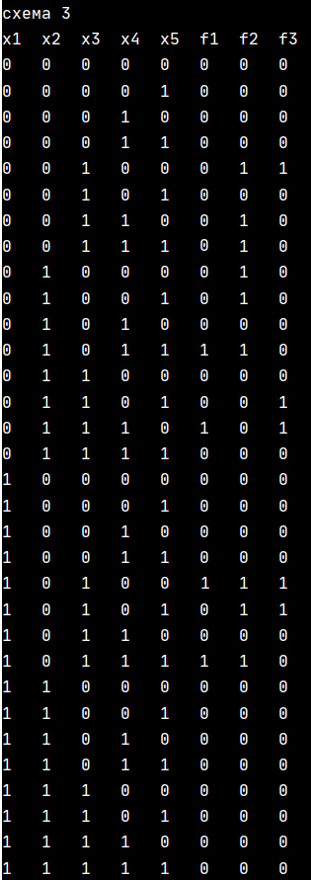

Схема 6 пункта

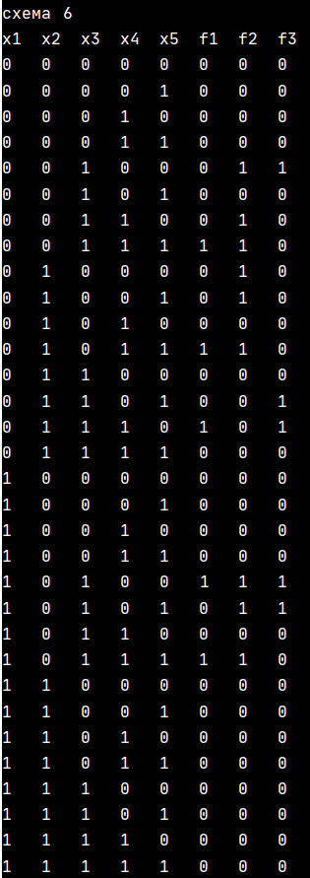 

7.Сравнить полученные в пунктах 3 и 5 схемы по Квайну и по быстродействию.

Схема пункта 3:  
Сложность по Квайну = 77  
Сложность по быстродействию =5

Схема пункта 5:  
Сложность по Квайну = 71  
Сложность по быстродействию =5